Date: _________________________________ 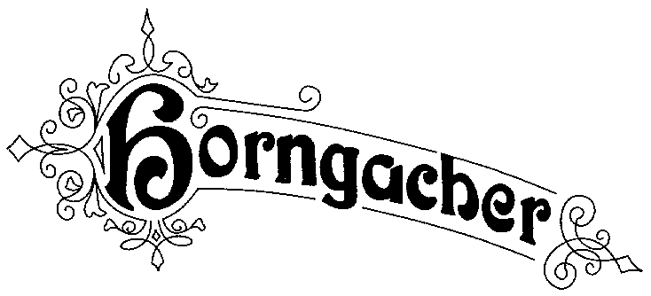
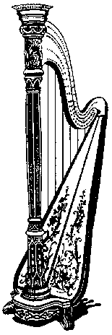
Konzertharfenbau
Horngacher GmbH
Söckinger Str. 23
D 82319 Starnberg
Tel.: 08151-1 29 20
Fax: 08151-2 12 04
Mobil: 0172-8 12 19 04
www.horngacher-harps.de
Klaus Horngacher
Registergericht München
HRB 99196
Ust-Id.Nr. DE 128 233 627
info@horngacher-harps.de
Sender:_________________________________

_______________________________________

Fax no.:________________________________

Tel. no.:________________________________ EMAIL__________________________________________

ORDERLIST FOR HARPSTRINGS

Pirastro normal/varnished:

Bow Brand:
Ni (nickel plated) Si (silver plated)
Nylon Pirastro/Bow Brand

Adress for delivery:...........................................................................................

...........................................................................................

...........................................................................................

Signature and date: ............................................................................................

